Three phase induction motors
In a dc motor, conductors on a rotating armature pass through a stationery magnetic field.
In three phase induction motor, the magnetic field rotates. This has the advantage that, there no electrical connections to be made to the rotor. The current in the rotor conductors is as a result of induced voltage in the rotor. The rotor is not supplied with any power.
Advantages of induction motor are:
- It is cheap and robust
- It is explosion proof due to the absence of commutators and brushes.
- Requires little or no skilled maintenance
- It is self-starting when switched on.
Disadvantages of induction motor are:
- The main disadvantage of an induction motor is that its speed cannot be readily varied.
Construction of a three phase induction motor
The stator of a three phase induction motor is the stationery part. It is wound to give a 2-pole, 4-pole, 6-pole etc. rotating magnetic field depending on the rotor speed required. The rotor is built up of laminated iron, to reduce eddy currents. There are two types of rotor constructions namely; squirrel cage rotor and wound rotor.
In squirrel cage rotor, copper or aluminium bars are placed in slots in the laminated iron, and the ends of the bars are welded or brazed into a heavy conducting ring. This type of rotor has no external connections which means that slip rings and brushes are not needed. The squirrel cage motor is cheap, reliable and efficient.
In wound rotor, there are phase windings in slots similar to those in stator. The windings may be connected in star or delta and the connections made to three slip rings. The slip rings are used to add external resistance to the rotor circuit particularly for starting but for normal running the slip rings are short circuited.
The principle of operation is same for squirrel cage and wound rotor machines.
$$Squirrel cage rotor$$
$$Wound rotor$$
$$slip rings$$
$$Stator$$
$$Rotor$$
$$Air-gap$$
$$Cross section view$$
$$R_{F}$$
$$R_{s}$$
$$Y_{s}$$
$$B_{s}$$
$$Y_{F}$$
$$B_{F}$$
Production of rotating magnetic field
When the stator windings are connected to a three phase supply, the current flowing in each winding varies with time as shown in the diagram below. The magnetic field produced has constant magnitude and rotates at constant speed called synchronous speed.
RED
YELLOW
BLUE
$${90}^{0}$$
$${120}^{0}$$
$$t_{1}$$
$$t_{2}$$
$$t_{3}$$
$$Time$$

At time $t_{1}$ the current flowing in the red phase is a maximum positive value. The currents flowing in yellow and blue phases are both 0.5 times the maximum value and are negative. The current distribution in the stator and the resulting magnetic field is shown in Fig.1.
At time $t_{2}$ the current in the red phase has reduced to 0.87 times the maximum value and is positive. The current in the yellow phase has reduced to zero. The current in the blue phase has increased to 0.87 times the maximum value and is negative. The current distribution in the stator and the resulting magnetic field is shown in Fig.2.
At time $t_{3}$ the current in the red phase has reduced to 0.5 times the maximum value and is positive. The current in the yellow phase has increased to 0.5 times the maximum value and is positive. The current in blue phase has increased to maximum but negative. The current distribution in the stator and the resulting magnetic field is shown in Fig.3.
Similar diagrams can be produced for all time values and these would show that the magnetic field travels through one revolution for each cycle of the supply voltage applied to the stator windings.

⊕
⊕
⊕
$$⊙$$
$$⊙$$
$$⊙$$
$$R_{s}$$
$$R_{F}$$
$$B_{s}$$
$$Y_{s}$$
$$B_{F}$$
$$Y_{F}$$
N
S
Fig. 1
⊕
⊕
$$⊙$$
$$⊙$$
$$R_{s}$$
$$R_{F}$$
$$B_{s}$$
$$Y_{s}$$
$$B_{F}$$
$$Y_{F}$$
N
S
Fig. 2
⊕
⊕
$$⊙$$
$$⊙$$
$$R_{s}$$
$$R_{F}$$
$$B_{s}$$
$$Y_{s}$$
$$B_{F}$$
$$Y_{F}$$
S
$$⊙$$
⊕
N
Fig. 3
Synchronous speed
The rotating magnetic field shown, which was produced by three phase windings, could have been produced by rotating a permanent magnet (shown as N and S in the Fig.1, 2 and 3) at synchronous speed. There it is called a 2-pole system and an induction motor using three phase windings only is called 2-pole induction motor.
Consider a case where six windings displaced from one another by ${60}^{o}$ are used as shown in Fig.4. By drawing current and the resultant magnetic field diagrams at various time values it can be shown that one cycle of the supply current to the stator windings causes the magnetic field to move through half a revolution. The current distribution in the stator windings for the time $t$ is also in Fig.4.
It can be seen that for six windings on the stator, the magnetic flux produced is the same as that produced by rotating two permanent magnet north poles and two permanent magnets south poles at synchronous speed. This is called a 4-pole system and an induction motor using six phase windings is called four pole induction motor. By increasing the number of phase windings, the number of poles can be increased to any even number.
Therefore in general, if f is the frequency of the stator winding currents, and the stator is wound to be equivalent to p pole pairs, then the speed revolution of the rotating magnetic field which is known as synchronous speed, $n_{s},$ is given by:
$$n_{s}=\frac{f}{p} rev/s$$
RED
YELLOW
BLUE
$$t$$
$$Time$$

$$R_{s}$$
$$R_{F}$$
$$B_{s}$$
$$Y_{s}$$
$$B_{F}$$
$$Y_{F}$$
S
N
⊕
⊙
⊕
⊕
⊕
⊕
⊕
⊙
⊙
⊙
⊙
⊙
$$R_{s}$$
$$Y_{F}$$
$$B_{s}$$
$$R_{F}$$
$$Y_{s}$$
$$B_{F}$$
N
S

Principle of operation of three phase induction motor
When three phase supply is connected to stator windings, a rotating magnetic field is produced. As the magnetic flux cuts the rotor bars, an emf is induced in it. Since the rotor ends are short circuited by a conducting ring, each bar is connected to another bar approximately pole pitch away and hence current flows in the bars. The direction of the current can be determined using the Fleming’s Right Hand Rule (generator rule). It important to note the rule assumes the conductors are the one in motion.
⊕
Direction of rotation of stator flux
Stator
Rotor
The current flowing in the rotor bars also sets up its own magnetic field whose direction can be determined by Right Hand Grip method or any other method. The rotor current magnetic field interacts with the rotating magnetic field and a force is produced. The direction of the force is determined using the Flemings Left Hand Rule (motor rule). As shown in the diagram the direction of the force is the same as the direction of the rotating magnetic field in the stator. Due to the force on two conductors making a loop which will be equal but opposite in direction, torque is produced in the rotor and therefore it starts rotating in the same direction as the rotating magnetic field.
⊕
Direction of rotation of stator flux
Stator
Rotor
Force
Slip
As explained the rotor rotates in the same direction as the rotating magnetic field. As the rotor speed increases, the rate at which the rotating magnetic field cut the rotor conductors reduces. If the rotor speed reaches synchronous speed, then there will be no induced voltage and hence no current in the rotor conductor and therefore no torque on the rotor. Thus the rotor slows down. The speed falls till the resultant relative speed is enough to produce torque equal to the losses and the load requirements. For this reason the rotor can never run at synchronous speed.
The difference between the rotor speeds$n_{r}$ and the synchronous speed $n_{s}$ is called slip speed.
$$Slip speed=n_{s}-n_{r} rev/s$$
When expressed as a ratio of synchronous speed it is called fractional slip or just slip.
$$Slip, s=\frac{n_{s}-n_{r}}{n_{s}}×100\%$$
Typical values of slip between no load and full load are about 4 to 5% for small motors and 1.5 to 2% for large motors.

Rotor frequency
The rotor emf is induced by an alternating flux and the rate at which the flux passes the conductors is the slip speed. Thus the frequency of the rotor emf is given by:
$$f_{r}=\left(n_{s}-n_{r}\right)p=\frac{n_{s}-n_{r}}{n_{s}} \left(n_{s}p\right)$$
$$Hence we have f_{r}=sf$$
Rotor emf
When induction motor is stationery, the stator and the rotor windings form the equivalent of a transformer, stator being primary and rotor the secondary.
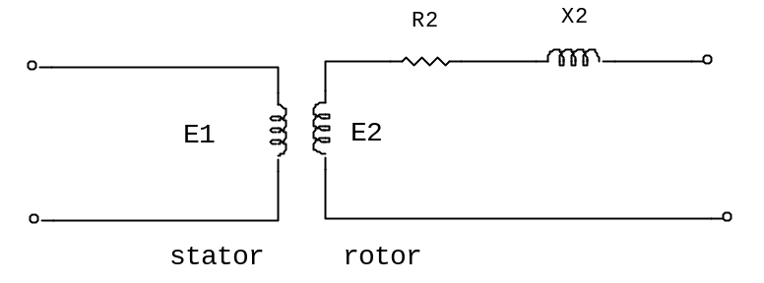
Hence the rotor emf at stand still is given by:
$$E_{2}=(\frac{N_{2}}{N_{1}})E_{1}$$
Where $E_{1}$ is the supply voltage per phase to the stator. When the induction motor is running, the induced emf in the rotor is les since the relative movement between conductors and the rotating field is less. The induced emf is proportional to this movement, hence it must be proportional to the slip, $s.$ Hence when running the emf per phase is given by:
$$E_{r}=sE_{2}=s(\frac{N_{2}}{N_{1}})E_{1}$$

Rotor impedance and current
Rotor resistance $R_{2}$ is unaffected by frequency or slip, and hence it remains the same under all slips.
The rotor reactance varies with the frequency of the rotor current.
At stand still, reactance per phase, $X_{2}=2πfl$
When running, reactance per phase, $X_{r}=2πf_{r}l=2π\left(sf\right)l=s\left(2πfl\right)=sX_{2}$
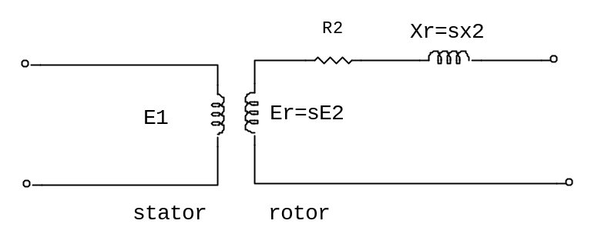
The impedance per phase, $Z_{r}=\sqrt{\left[{R_{2}}^{2}+{(sX_{2})}^{2}\right]}$
At stand still, slip$s=1$, then $Z_{2}=\sqrt{\left[{R_{2}}^{2}+{X_{2}}^{2}\right]}$
Rotor current
At stand still starting current is, $I_{2}=\frac{E_{2}}{Z_{2}}=\frac{(\frac{N_{2}}{N_{1}})E_{1}}{\sqrt{\left[{R_{2}}^{2}+{X_{2}}^{2}\right]}}$
When running the current is, $I_{r}=\frac{E_{r}}{Z_{r}}=\frac{s(\frac{N_{2}}{N_{1}})E_{1}}{\sqrt{\left[{R_{2}}^{2}+{{(sX}_{2})}^{2}\right]}}=\frac{skE_{1}}{\sqrt{\left[{R_{2}}^{2}+{{(sX}_{2})}^{2}\right]}}$
Rotor copper loss
Power $P=2πnT, where T is torque$ in newton meters. Hence:
$$T=\frac{P}{2πn}$$
If $P_{2}$ is the power input to the rotor from the rotating field, and $P_{m}$ is the mechanical power output (including frictional losses), then:
$$T=\frac{P_{2}}{2πn_{s}}=\frac{P_{m}}{2πn_{r}}$$
From which:
$$\frac{P_{2}}{n_{s}}=\frac{P_{m}}{n_{r}} or \frac{P_{m}}{P_{2}}=\frac{n_{r}}{n_{s}}$$
Hence:
$$1-\frac{P_{m}}{P_{2}}=1-\frac{n_{r}}{n_{s}}$$
$$\frac{P_{2}-P_{m}}{P_{2}}=\frac{n_{s}-n_{r}}{n_{s}}=s$$
$P_{2}-P_{m}$ is the electrical or copper loss in the rotor, i.e. $P_{2}-P_{m}={I_{r}}^{2}R_{2}$
Hence:
$$s=\frac{rotor copper loss}{rotor input}=\frac{{I_{r}}^{2}R_{2}}{P_{2}}$$
Or power input to the rotor, $P_{2}=\frac{{I_{r}}^{2}R_{2}}{s}$
$$P_{2}=\frac{s^{2}k^{2}{E_{1}}^{2}}{{R_{2}}^{2}+{{(sX}_{2})}^{2}}. \frac{R_{2}}{s}=\frac{s^{2}k^{2}{E_{1}}^{2}R_{2}}{s^{2}\left[{\left(\frac{R_{2}}{s}\right)}^{2}+{X_{2}}^{2}\right]}. \frac{R_{2}}{s}=\frac{k^{2}{E_{1}}^{2}}{{\left(\frac{R_{2}}{s}\right)}^{2}+{X_{2}}^{2}}.\frac{R_{2}}{s}$$
$\frac{R_{2}}{s}$ can be broken down into $R_{2}$ which represents the inherent part of the internal impedance of the rotor of the machine and $R_{2}\frac{1-s}{s}$ which represents the electrical analogue of the mechanical load (or output) of the motor.
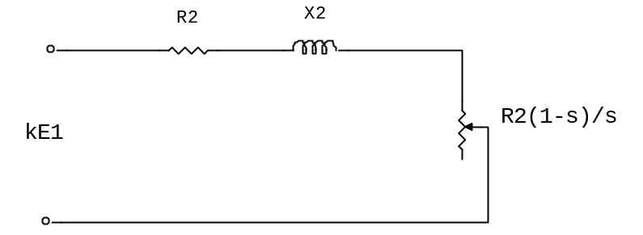
The mechanical power output is given by:
$$P_{m}={I_{r}}^{2}R_{2}\frac{1-s}{s}=\frac{k^{2}{E_{1}}^{2}R_{2}}{{\left(\frac{R_{2}}{s}\right)}^{2}+{X_{2}}^{2}}\frac{1-s}{s}$$
$${NOTE:(P}_{2}-P_{m})={I_{r}}^{2}R_{2}=rotor copper losses as shown above$$
From above equation for${ P}_{m}$, it is clear that $P_{m}=0$ when $s=0$ and$s=1$. These means the output of an induction motor is zero when it is running at synchronous speed and at stand still. Further the sign of the power depends upon the magnitude and sign of slip, $s$ as outlined below:
First case: slip, s is positive$0<s<1$. The motor speed lies between zero and synchronous speed and the direction of rotation of the rotor is the same as that of the stator field. The power, P is therefore positive and indicates the motor action of the machine.
Second case: slip, s is negative$s<0$. The rotor rotates in the same direction as the stator field but at a speed higher than the synchronous speed. The relative direction of rotation of the rotor and magnetic field in the rotor are reversed which induces current and voltage in the rotor circuit in the reverse direction. This means the machine acts as a generator.
Third case: slip, s is greater than unity $s>1.$ The rotor is physically rotating in the opposite direction to the rotation of the stator field. The rotor currents and voltage induced are in the same direction as in first case, but are greater due to the higher relative speed. The machine acts as an electric brake and thus power is negative.
Torque equation for an induction motor
$$T=\frac{P_{2}}{2πn_{s}}=\left(\frac{1}{2πn_{s}}\right)\left(\frac{{I_{r}}^{2}R_{2}}{s}\right)$$
But:
$I_{r}=\frac{s(\frac{N_{2}}{N_{1}})E_{1}}{\sqrt{\left[{R_{2}}^{2}+{{(sX}_{2})}^{2}\right]}}=\frac{skE_{1}}{\sqrt{\left[{R_{2}}^{2}+{{(sX}_{2})}^{2}\right]}}$
Hence torque per phase is:
$$T=\left(\frac{1}{2πn_{s}}\right)\left[\frac{s^{2}k^{2}{E_{1}}^{2}}{{R_{2}}^{2}+{{(sX}_{2})}^{2}}\right]\left(\frac{R_{2}}{s}\right)$$
$$T=\left(\frac{1}{2πn_{s}}\right)\left[\frac{sk^{2}{E_{1}}^{2}R_{2}}{{R_{2}}^{2}+{{(sX}_{2})}^{2}}\right]$$
For a three phase system, we have:
$$T=\left(\frac{3}{2πn_{s}}\right)\left[\frac{sk^{2}{E_{1}}^{2}R_{2}}{{R_{2}}^{2}+{{(sX}_{2})}^{2}}\right]$$
$$T=k_{T}\left[\frac{s{E_{1}}^{2}R_{2}}{{R_{2}}^{2}+{{(sX}_{2})}^{2}}\right]$$
Where $k_{T}$ is a constant for a particular machine.
$$Tα\frac{s{E_{1}}^{2}R_{2}}{{R_{2}}^{2}+{{(sX}_{2})}^{2}}$$
Under normal conditions, the supply voltage is usually constant, hence we have:
$$T α \frac{sR_{2}}{{R_{2}}^{2}+{{(sX}_{2})}^{2}} α \frac{R_{2}}{\frac{{R_{2}}^{2}}{s}+{{sX}_{2}}^{2}}$$
The torque will be maximum when the denominator is minimum and this occurs when $\frac{{R_{2}}^{2}}{s}={{sX}_{2}}^{2}$ or${ R}_{2}={sX}_{2}=X_{r}$.
Therefore maximum torque occurs when the rotor resistance and the rotor reactance are equal, i.e.
$${ R}_{2}=X_{r}$$
Below are typical torque-speed characteristics for forward and reverse direction of rotation:
$$ω$$
S=0
S=1
S=0
T
Case I:
Forward motoring
Case II:
Plugging
Case III:
Reverse motoring
$$T_{M}$$
The regenerative action of the machine when the rotor rotates in the forward direction, at a speed greater than the synchronous speed, is shown by the curve in the second quadrant (forward motor curve).
The torque speed characteristic of a three phase induction motor can be modified by the following methods:
- Application of reduced voltage
From (4) and (5) it is clear that the torque is promotional to square of voltage and the slip at which the maxim torque occurs is independent of voltage applied.
0.5V
V
0.7V
T
$$ω$$
$$ω_{s}$$
It is clear that the speed difference corresponding to maximum torque and synchronous speed is independent of the applied voltage.
- Application of variable frequency
The speed is a function of frequency as given by the equation $f=\frac{np}{120}$.while varying frequency, it is necessary to see that motor retains its shunt characteristics and has adequate overload torque capacity. Both these objectives are achieved by maintaining air gap flux constant. For an induction motor$V_{1}αf∅ or \frac{V_{1}}{f}=k∅$. Therefore in order to maintain constant air gap flux, $\frac{V_{1}}{f}$ should be kept constant. A set of torque speed characteristics are shown below using variable frequency control.
$$f_{1}$$
T
$$ω$$
$$f_{2}$$
$$f_{3}$$
It can be seen that the maximum torque decreases with decease in frequency below normal frequency. Also with decrease in frequency the slip at which maximum torque occurs also decreases.
- Addition of rotor resistance
The torque speed characteristic can be modified by inserting resistance in the rotor circuit. Different characteristics for different rotor resistances are shown in the diagram below:
$$R_{2}$$
T
$$ω$$
$${4R}_{2}$$
$${2R}_{2}$$
From the diagram it is seen that the magnitude of the maximum torque is independent of the rotor resistance but the slip at which the maximum torque occurs is directly proportional to the rotor resistance.
- Pole changing
A squirrel cage rotor is not wound for a specific a specific number of poles, rather it adapts to the same number of poles as the air gap magnetic field, which is determined by the stator winding. The stator winding can be reconnected to multiply the number of poles by a factor of two for a single motor winding. If the motor has two distinct stator windings then the synchronous speeds can be obtained again by reconnecting the windings suitably.
- Voltage injection in rotor circuit
Assuming constant supply voltage frequency and load torque and neglecting voltage drop in the stator, the applied voltage$V_{1}≅E_{1}=k∅=constant$. The induced voltage in the rotor is ${sE}_{2}$ where $s$ is slip and $E_{2}$ induced emf at stand still condition. Therefore rotor current:
$$I_{2}=\frac{{sE}_{2}}{{(R_{2}^{2}+{\left(sX_{2}\right)}^{2})}^{1/2}}$$
Normally$_{2}^{2}≫{\left(sX_{2}\right)}^{2}$, therefore current $I_{2}$is almost in phase with $E_{2}$and is approximately$\frac{sE_{2}}{R_{2}}$.
Now if emf $E_{j}$, opposite in phase to $E_{2}$is injected into the rotor (wound rotor), then initially due to inertia of the rotor, the speed cannot change instantaneously and hence net emf in the rotor circuit reduces to ${sE}_{2}-E_{j}$, as a result of which the rotor current and hence the torque developed decrease. With load torque remaining constant, the speed decreases (slip increases). This process continues till new slip $s_{j}>s$ is achieved, when the rotor induced emf increases to circulate enough current in the rotor to develop electrical torque required.
Similarly if the injected emf is in phase with the rotor induced emf, the speed of the motor will increase. The injected emf has to be at slip frequency.

